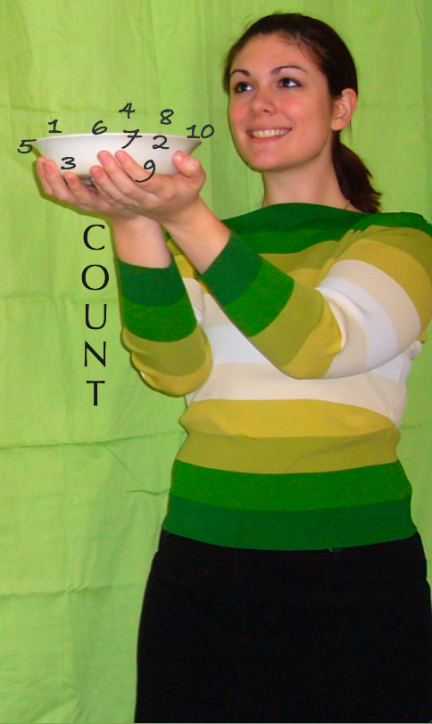

**MORE MATH PLEASE**

By: Angela Wedgwood

*Adapted from Rachel Billmeyer, Strategic Reading in the Content Areas- Volume I (2004) and Strategies to Engage the Mind of the Learner- Volume II (2006)*



**TABLE OF CONTENTS**

Introduction …………………………………………………………………. pg. 2

BEFORE READING STRATEGIES

* **KWL** ………………………………………………………………………. pg. 4
* **Give One To Get One** …………………………………………………….. pg. 7
* **Facts and Fibs** …………………………………………………………….. pg. 11

DURING READING STRATEGIES

* **Think Aloud** ……………………………………………………………… pg. 13
* **Pairs Read** ……………………………………………………………….... pg. 16
* **Summary Wheel** ………………………………………………………….. pg. 19

AFTER READING STRATEGIES

* **Problem Solving Plan** …………………………………………………….. pg. 23
* **The Raft Strategy** ………………………………………………………… pg. 27
* **M.V.P.** ……………………………………………………………………. . pg. 31
* **Semantic Feature Analysis** ……………………………………..………... pg. 34
* **Four Step Process** ……………………………………………………….... pg. 37
* **Concept Definition Mapping** …………………………………………….. pg. 41

About the Author …………………………………………………………... pg. 45

References …………………………………………………………………… pg. 46

**INTRODUCTION**

As an educator it is important to keep in mind the tool that mediates every student’s success, that is, ones innate ability to learn. Although innate, the process to which the degree one can learn must be developed. It is thorough reading that students’ develop such processes and it is through educators’ that students’ develop metacognition. Rachel Billmeyer, an acclaimed education consultant has said, “Reading is thinking cued by text”. Teaching students to read successfully allows students’ to take control of their own development. It is through reading strategies a student learns to comprehend difficult text. Once a student has mastered a strategy, he or she will then be able to use it in other content areas and the value of the strategy will become endless.

Every academic content area involves reading and comprehension, which is the process of making meaning from written text, becomes essential to every student’s success. Therefore, it is important for teachers to incorporate strategies into their lesson plans in order to meet the needs of their students. Taught successfully, students will make it their own and will be able to apply the learned strategies throughout their lives. Successful application of strategies not only engages students in thought and concept but more importantly they increase the confidence level of students as well.

The following strategies I have chosen were adapted from Rachel Billmeyer’s books titled, Strategies to Engage the Mind of the Learner-Volume II (2006) and Strategic Reading in the Content Areas-Volume I (2004).

**Before**

**Reading**

**Strategies**



**K-W-L**

**(what I Know, what I Want to know, what I have Learned)**

**What is the strategy?**

The **“K-W-L**” is a **before** reading strategy that is used to increase reading comprehension. The strategy helps students identify what they already know about a topic and what they expect to know prior to reading about the topic. Not only does this strategy help students to connect new information with prior knowledge it also can help the teacher assess gaps or misconceptions students may have before a unit is underway.

### How do you use the strategy?

1. Students can work individually or as a small group.
2. Students will receive a prepared handout with three columns labeled K-W-L, an acronym for “What I **k**now, What I **w**ant to know and What I have **l**earned”.
3. To begin, students are asked to identify everything they “Know” or “think they know” about the topic selected for reading in the “K” column.
4. Students’ ideas are then categorized as the information is recorded. (Categorization of information will also assist in the students’ retention process. Students are asked to set a goal).
5. Students are asked write what they “Want to Learn” about the topic in the “W” column.
6. Lastly, students are asked to read the selected topic and then asked to answer the questions recorded in the “W” column. Once the students have done so, they should then identify all of the new information they have learned through their reading and record it in the “L” column. Should students realize that what they thought they knew about the topic was incorrect then the corrected learning is to be recorded in the “L” column.

### What students benefit the most from this strategy?

The students who benefit from this strategy are those who have difficulty synthesizing information. This strategy will allow students to use the inductive and deductive reasoning necessary to organize information and in return make connections to new concepts.

**K-W-L**

Blank Template

|  |  |  |
| --- | --- | --- |
| **What I Know** | **What I Want to Know** | **What I Learned** |
|  |  |  |

**Completed Example:** What is Algebra and how will it help me in the real world?

|  |  |  |
| --- | --- | --- |
| **What I Know** | **What I Want to Know** | **What I Learned** |
| A branch of mathematics that substitutes symbols and letters for numbers | Why do we use symbols and letters to represent numbers in algebra? | Any time we want to talk about a number without having to know its value we can give it a name and talk about it. It is like using ones own name rather than a having a picture of you when you write about yourself; or using the pronoun he or she instead of your name in a document that might have been written with reference to anybody.  It allows us to talk about things that are very hard to talk about in any other way. |

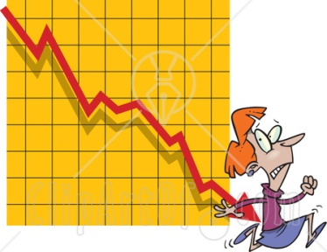

**Give One to Get One**

### What is this strategy?

Give One To Get One is a very popular strategy that is generally used as a during or after reading strategy. Yet, “thinking outside the box” as the saying goes is what educators do best therefore, this strategy should also be considered as a **before** reading strategy. As a before reading strategy, The “Give One To Get One” can be used to help students prepare their thoughts before reading text. The strategy will allow students to build upon prior knowledge about a topic to be studied. In doing so, the students can then be prompted to make predictions about what is yet to come in preparation of a new unit of study. By the time students reach their secondary education years the four unit studies of math (algebra, probability/statistics, geometry and trigonometry) are familiar ground. The only thing that changes is the concepts become a little more complex. Therefore, use of this type of interactive strategy is a fabulous way to break ground as a new unit of study makes way. This strategy can subtly force prior knowledge to surface in a fun and engaging style of learning. Once prior knowledge has surfaced students become more relaxed and are not quite as intimidated by the process of the increasingly more difficult steps they will need to conceptualize within the one subject many consider as the “dreaded” world of mathematics. They can then have fun making predictions as to what is yet to come and the fear of learning should ultimately weaken.

### How do you use this strategy?

1. Students are given a grid of questions to answer in each box. Students will work independently to complete the questions to the best of their ability.
2. When completed the students will form small groups and in a round-robin style will “Give One to Get one” with their group members. Group members will listen to each other, paraphrase, ask questions, and build off of each other’s thoughts and responses.
3. Students will continue this process until the entire group has shared.
4. In the end the students will develop a mutual question to share with the class to which they still do not have an answer.

### What students will benefit the most from this strategy?

The students who benefit the most from this type of strategy are those students who have a problem retrieving information cognitively. With the arrangement of peer sharing, students with this type of problem feel less stressed and more comfortable before beginning the learning process. Students who are able to retrieve prior information more readily benefit from the discussions since they can more actively build off of one another’s personal knowledge.

**Give One to Get One**

Blank Template

|  |  |  |
| --- | --- | --- |
| **Question:**  **Answer:** | **Question:**  **Answer:** | **Question:**  **Answer:** |
| **Question:**  **Answer:** | **Question:**  **Answer:** | **Question:**  **Answer:** |
| **Question:**  **Answer:** | **Question:**  **Answer:** | **Question:**  **Answer:** |

**Give One to Get One**

**Completed Example:**

|  |  |  |
| --- | --- | --- |
| In your own words, describe why statistics is a part of mathematical science?  Answer: Statistics is a mathematical science pertaining to the collection, analysis, interpretation or explanation of data. It also provides tools for prediction and forecasting based on data. | Name one real world problem you can use statistics for.  **Answer:** Census analysis | What purpose do you feel that graphs have in the application of statistics?  **Answer:** To show a relationship between changing things. Also they are a visual diagram |
| Name the types of graphs you are familiar with.  **Answer:** Bar Graphs  Double Bar Graphs, Stem and Leaf Plots, Line Graphs, Histogram, Circle Graph, Pictograph… | What is another name for a circle graph?  **Answer:** Pie Chart | What does it mean when you are asked to collect data?  **Answer:** The process of preparing data. |
| What does it mean when you are asked to interpret data?  **Answer:** Through use of statistical tools such as charts and mapping you can measure and establish relationships the data is pointing to | What does it mean when you are asked to display data?  **Answer:** One of the most popular tools to display data is by use of graphs | Can you name the three kinds of averages (clue: they all start with the letter “M”?  **Answer:** Mean, Median, Mode |

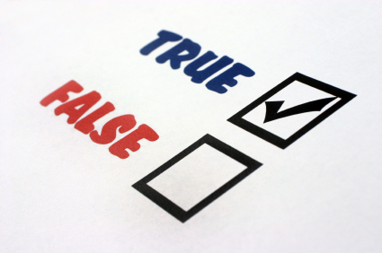

**Facts and Fibs**

### What is this strategy?

Facts and Fibs is a **before** reading strategy. This strategy is a great ice-breaker, it can be used before beginning a new unit, the end or a unit or somewhere in-between. The Facts and Fibs strategy will help to develop a risk-taking environment promoting students to share.

### How do you use this strategy?

1. The teacher will first explain the purpose of the strategy.
2. She/he will then model the strategy for the students by filling in two true and one false statement’s into an elongated grid template. The statements will then be shown on an overhead.
3. She/he will then ask the students to determine which statement is a fib and why it is a fib.
4. Students will then be asked to create two factual statements and one fib about math terms they have learned in the past week.
5. Students will be split off into groups of size 3 or 4. Students will then be asked to share their three statements one at a time while the others in the group.
6. Students will then determine which statement is a fib then must tell why the statement is a fib and reword it as a true fact about the topic.
7. When all groups have completed the teacher will ask the students to share, one at a time, something they have learned about a term they may not have been familiar with or understood correctly.
8. Meanwhile, the teacher will go from group to group making sure that the terms shared are correct in venue.

### Who will benefit the most from this strategy?

The Facts and Fibs strategy is beneficial for students who normally prefer to work independently. Students such as this may enjoy this type of group activity for they can show off their knowledge and because this is a safe environment they can get very tricky with their fib if they prefer to do so. Since this activity is all in fun no one is none the wiser to their game plan.

Blank Template

|  |  |  |  |
| --- | --- | --- | --- |
| **Question** | **Fact** | **Fib** | **If Fib, Why?** |
| **1.** |  |  |  |
| **2.** |  |  |  |
| **3.** |  |  |  |

**Completed Example:**

|  |  |  |  |
| --- | --- | --- | --- |
| **Question** | **Fact** | **Fib** | **If Fib, Why?** |
| **1.** A polynomial is a mathematical function that is the sum of a number of terms? | **check_mark.jpg** |  |  |
| **2.** A trinomial is a mathematical function consisting of three terms? | check_mark.jpg |  |  |
| **3.** A monomial means three different things in the context of polynomials? |  | check_mark.jpg | A monomial means two different things in the context of polynomials |

**C:\Documents and Settings\Nikki\Local Settings\Temporary Internet Files\Content.IE5\D3ON6GXK\j0436129[1].wmf**

**Think – Aloud**

### What is this strategy?

Think-Aloud is a **during** reading strategy. This strategy helps students through the thinking process, a covert process that in turns becomes an overt process. It is a meta-cognitive strategy that causes students to think about their own thinking. Think-Aloud allows the student to figure out the analogy behind the reading, along with helping the student to plan, reflect and organize the information in order to process it. This strategy helps to keep the students actively engaged in the text.

### How do you use this strategy?

1. The Think-Aloud strategy works with two students taking turns reading portions of a text while the other reads and jots down notes about whatever comes into their mind. Examples such as:

* What is going to happen next?
* How does this section of the text relate to the rest?
* I am not sure what that word means?

1. While the student is thinking aloud by writing notes he/she is predicting, questioning, connecting, and clarifying the material and visualizing it at the same time. (This strategy also helps the student along metacognitively during that “I get it” moment.
2. When the reader completes their portion of the reading the note taker then shares his/her notes and together they reflect on the completed reading.
3. Roles are then switched and continue until the reading is complete.

**Who will benefit the most from this strategy?**

The students who benefit from the Think-Aloud strategy are the students who have trouble focusing on text. Usually those who struggle may know how to decode words but have trouble making meaning out of what they are reading. This strategy will help students understand how the mind constructs meaning when reading and how to think through difficult spots.

Blank Template

|  |  |
| --- | --- |
| **Word** | **I’m not sure what this means** |
|  |  |
|  |  |
|  |  |

**Think – Aloud**

**Completed Example:**

|  |  |
| --- | --- |
| **Word** | **I’m not sure what this means** |
| **Descriptive Statistics** | Used to describe the basic features of the data gathered from an experimental study in various ways |
| **Data** | Refers to information or facts usually collected as the result of experience, observation or experiment, or processes within a computer system, or premises. |
| **Experiment** | In scientific inquiry, an experiment is a method of investigating causal relationships among variables |

**Example Text Used**

Descriptive Statistics are used to describe the basic features of the data gathered from an experimental study in various ways. Data in terms of descriptive statistics refers to information or facts usually collected as the result of experience, observation through experiment but can also be used to refer to processes within a computer system, or premises. In scientific inquiry, an experiment (Latin: *ex- periri*, "to try out") is a method of investigating causal relationships among variables.



**Pairs Read**

### What is this strategy?

Pairs Read is a **during** reading strategy. This strategy introduces a social aspect to the classroom environment and provides development of listening skills as well as reading skills to the students.

### How do you use this strategy?

1. The Pairs Read strategy works as one student reads the text aloud the other student takes notes on the text of any information they think may be of importance.
2. Once the student has completed their section of the reading the student taking the notes reads back what it is they wrote from their notes and the reader summarizes what they just read.
3. Once completed, the paired students work together to develop some key ideas from the section read and reverse roles and repeat until the reading is completed.

### Who benefits the most from this strategy?

The Pairs Read strategy is beneficial for learners who struggle with retaining facts from complicated text. The strategy is also beneficial to those students who lack interest in reading. Since we are social creatures by nature, Pairs Read, is a great strategy to motivate even the most unmotivated student.

**Pairs Read**

Blank Template

|  |  |
| --- | --- |
| **“Pairs Read” NOTES** | **KEY IDEA’S** |
|  |  |

**Pairs Read**

**Completed Example:**

|  |  |
| --- | --- |
| **“PAIRS READ” NOTES** | **KEY IDEA’S** |
| * NBA players make a lot of money, right? * How much do they make, and is it really as much as you think it is? * So how much does the typical NBA player make? * But does the average always tell the whole story? * Every year, a few top notch players like Shaq make much more money than anybody else. * So what can you report, other than the average, to show what the salary of a “typical” NBA player would be? * The median is still an unsung hero of statistics in the sense that it isn’t used nearly as often as it should be, although people are beginning to report it more and more nowadays. * The median salary for the Lakers is well below the average of $4.2 million for this team. | * Compared to most people, they certainly do. * The answer depends on how you choose to summarize the information. * One way to answer this is to look player’s average salaries. * In some cases the average is misleading. * These are called outliers (numbers in the data set that are extremely high or extremely low compared to the rest of the data). * Another statistic that is used to measure the center of a data set is called the median. * The median of a data set is the value that lies exactly in the middle. * Because the average Laker salary includes outliers, the median salary is more representative of the middle salary for the team. |

### http://www.autoclipart.com/stuff/thumbs/2945412.gif

**Summary Wheel**

### What is this strategy?

The Summary Wheel is a **during** reading activity. The Summary Wheel strategy is a wonderful activity for students since it helps to organize reading in a visual manner. The students are able to see the important main ideas and details organized around this wheel. The strategy helps to create concise, meaningful summaries of the reading.

### How do you use this strategy?

1. After students complete a section of the text, they summarize what they have just read in each piece of the Summary Wheel.
2. The students can include important themes, vocabulary, names, events or any details they feel may be relevant to the text. The Summary Wheel pushes students to reflect what it is they just read.
3. Once the “wheel” is complete students can form into groups and share their wheel with each other. The students will retain more as they compare and contrast main ideas and why they felt it necessary to be a part of the wheel.

### Who will benefit the most from this strategy?

This strategy benefit’s visual learners as well as learners who struggle with organization. A graphic organizer of this sort helps students to see visually a perfected outline of what they have just read.

**Summary Wheel**

Blank Template

**Summary Wheel**

**Completed Example:**

AAS Congruence AA Similarity Angle Alternate Interior Angle

**AFTER**

**READING**

**STRATEGY**

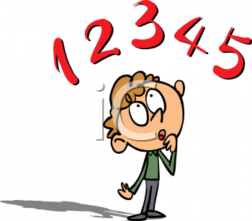

**Problem Solving Plan**

### What is this strategy?

### Problem Solving Plan is an after reading strategy. A very important part of math is the ability to understand what a problem is saying. Word problems pose to be the most difficult for students in the field of mathematics. The Problem Solving Plan strategy therefore helps to make problem solving easier for students because it forces prior knowledge. When students are able to use prior knowledge to construct meaning the problem itself becomes a source of that meaning.

### How do you use this strategy?

Implementing the Problem Solving Plan strategy into a lesson plan is simple.

1. First the teacher will display the word problem on an overhead and read it aloud to the students.
2. She/he will then translate the problem into a form of a “story” by relating it to prior knowledge.
3. Next, the teacher will underline the information in the problem that is critical for finding the solution then emphasize different ways in which the students can think about the problem and still get the correct answer.
4. Once the problem is solved the answer is recorded. The students are then asked to work with a partner to complete another problem. A diamond-shaped graphic organizer is handed out to assist in the problem. Lastly, several more problems should be assigned for the students to complete so that they can get the hang of using this strategy.

### Who will benefit the most from this strategy?

The Problem Solving Plan strategy can be used with any type of math problem at any grade level. The graphic organizer is used to guide their thinking and eventually the students will be able to solve word problems without a guide.

**Example Problem:** Harry Potter has asked his friend Hermione for a potion to turn them and their friend Ron into birds. (The flying car is in for repairs, so they need to make the trip to Diagon Alley as birds.)

Diagon Alley is 9 miles away and a dose of Hermione's potion lasts 50 minutes. They only have enough of the potion for one dose each. If they can go 24 miles an hour as birds, and they start at 4:30 p.m., can they get to Diagon Alley and back to Hogwarts again before the potion runs out at 5:20 p.m.? If so, how much time will they be able to spend in the Alley?

**Problem Solving Plan**

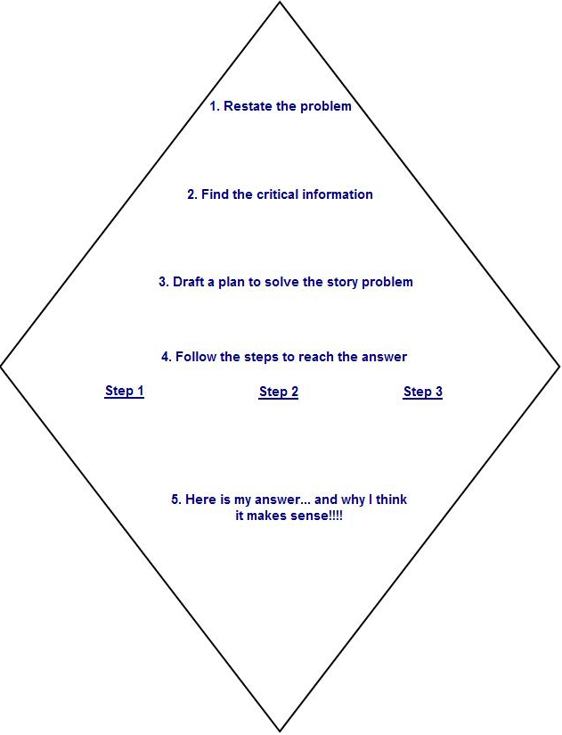

Blank Template



**Problem Solving Plan**

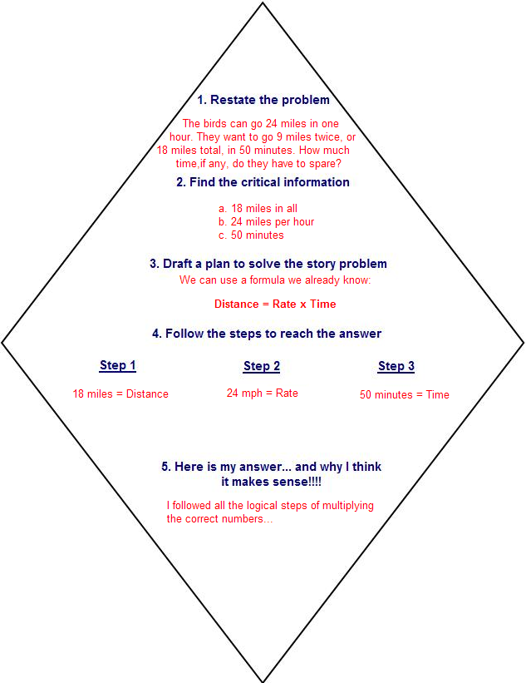

**Completed Example:**

****

**THE RAFT STRATEGY**

**What is this strategy?**

The RAFT strategy is an **after** reading strategy that offers a meaningful way for students to incorporate writing in any content area. RAFT is an acronym for **“R”**- Role of Writer, **“A”**- Audience, **“F”**- Format and **“T”**- Topic. Students who use the RAFT strategy learn more about the content since the strategy requires them to actively interact with the information at a higher level of cognitive processing. RAFT motivates writes by allowing students to be creative and react on a personal level. RAFT also provides students with a structured organizational pattern for writing.

**How do you use this strategy?**

1. A teacher will select a unit of study and determine the important information she/he feels the students need to know.

2. The teacher will next prepare a template of writing activity examples.

3. The students will choose a “Role” from the list of activities and assume the “Audience, Format, and Topic” provided along with the role chosen and perform a writing sample as indicated.

Note: The Raft Strategy can be used individually or with groups of students. This activity is fun, challenging, and creative. This is an excellent strategy to use as a tiered activity project.

**Who will benefit the most from this strategy?**

The students who will benefit the most from this type of strategy are those students who have trouble with recall. Since this activity allows the mind to create in the students own terms and peers are there to help with the retrieval process the student should be more relaxed. When a student is relaxed he/she is more apt to process. Altogether this strategy is great for all types of learners. The RAFT strategy helps students to learn more content since they are actively interacting with information at a higher level of cognitive processing. Therefore, students of all levels not only will increase their understanding but the concepts become more focused and the interpretation of the subject will expound.

**THE RAFT STRATEGY**

LETS GO RAFTING

Blank Template

|  |  |  |  |
| --- | --- | --- | --- |
| **Role** | **Audience** | **Format** | **Topic** |
|  |  |  |  |
|  |  |  |  |
|  |  |  |  |
|  |  |  |  |
|  |  |  |  |

**THE RAFT STRATEGY**

**Completed Example:**

|  |  |  |  |
| --- | --- | --- | --- |
| **Role** | **Audience** | **Format** | **Topic** |
| Bar Graph | Vendor | Sales Pitch | Why are bananas’ more popular than apples, oranges or pears this month? |
| Line Graph | Bank Investors | Notes for meeting | Why sales have plummeted to an all time low? |
| Double Bar Graph | Veterinarian | Letter | How many hours a day my cat sleeps, eats and plays compared to my dog |
| Stem and Leaf Plot | Teacher | Letter | Response to a low grade received on last exam compared to the last 8 quiz scores |
| Circle Graph (a.k.a. Pie Graph) | Friends | Obituary | Why my eating habits lead me to an early grave |

Dear Fruits “R” Us Vendor,

As the senior “bar” executive of Move “Em” and Expand The Bar Company, I wanted to give you a heads up on this month’s hottest selling fruit. I have been watching my bar members movements and have noticed that Timothy Bar has been going banana’s over banana’s. I truly believe that if you increase your inventory you will peel away from the competition. On a side bar, I would also like to point out Mandy Bar has been noticing a drop in sales on apples. You might want to peer up instead with Total Pear Company as they are beginning to move steadily up the charts.

Sincerely,

Barred for Life

****

**M.V.P**

**What is this strategy?**

M.V.P. is an acronym for **M**ost **V**aluable **P**oint.This is an **after** reading strategy which can help the reader decipher what information is most important in a text. This strategy is wonderful for students who struggle with understanding what they had just read.

**How do you use this strategy?**

1. The M.V.P. Strategy takes place while students read a text or a problem

2. The students will take notes on anything they feel is a key point or idea. Doing so, the student is actively engaging in the text or problem set and seeking out the key idea.

3. Once the student has completed the reading they can rank the key idea(s) in order from the most important to the least important.

4. The teacher can form students into pairs or small groups to share their most valuable points and compare them with their peers.

5. The students then decide together what they feel is the “most valuable point” and one person from the group can be chosen to share it with the class.

**Who will benefit the most from this strategy?**

The M.V.P. Strategy benefits those students who struggle with focusing and retaining information. Given a goal during a reading assignment can help guide the student reader to help him/her retain what they have just read.

**M.V.P**

Blank Template

**Student**  **Group**

**Completed Example:**

**Student**  **Group**

The Arithmetic Mean is the most commonly used type of average

Yes, The Arithmetic Mean is the most commonly used type of average, but more importantly it is also a number that represents the center of a set of values.

**VOCABULARY**

**STRATEGIES**

****

**Semantic Feature Analysis**

**What is this strategy?**

The Semantic Feature Analysis is a strategy very helpful for special education student needs. The strategy helps students to determine what a word means by comparing it to other words from the same category. A matrix grid is used to give students a visual representation of key words or terms that are associated with the category and specific features of each word. Semantic Feature Analysis is an excellent strategy to use when introducing new vocabulary and terms as a new unit of study is introduced. The strategy is extremely helpful when terms are very similar. In mathematics terms can often become confusing as when students are reaching upper level study. Terms begin to look similar if glanced at too fast and therefore the students can become confused as to what is expected of them to do. An example might be as with the term, polynomial/polygon. A polynomial is a mathematical function that is the sum of a number of terms whereas a polygon is a closed plane figure bounded by straight sides. Use of Semantic Feature Analysis Strategy will remind students to how the words are alike and different.

**How do you use this strategy?**

1. The teacher will select a category i.e. a unit of study. Terms used within this study will be filtered out.
2. He/She will then prepare a grid table with the key terms used. The grid will consist of a right column that will be utilized to enter terms used. The features of terms will be stated across the top row.
3. Students will then be directed to mark an **“X”** when the feature applies to the given term.
4. As terms are used or introduced throughout the unit, the teacher will immediately add them into the category list and then define them by checking the features that apply to them.

**Who will benefit the most from this strategy?**

The Semantic Feature Analysis strategy will benefit the special education learner the most. Many special needs students sometimes have difficulty pulling up prior knowledge or connecting previous knowledge to real life situations. Therefore, any strategy that is a graphical representation can help students to visualize critical attributes of terms within a category and serve as a tool for students to retain the knowledge through imagery.

**Semantic Feature Analysis**

Blank Template

|  |  |  |  |  |  |
| --- | --- | --- | --- | --- | --- |
| **Term(s)** |  |  |  |  |  |
|  |  |  |  |  |  |
|  |  |  |  |  |  |
|  |  |  |  |  |  |
|  |  |  |  |  |  |

**Completed Example:**

|  |  |  |  |  |  |
| --- | --- | --- | --- | --- | --- |
| **Fractions** | Common Denominator | Use operation on numerator only | Use operation on numerator and denominator | Use reciprocal of one fraction | Reduce to simplest form |
| Adding | **checkmark-and-x.jpg** | **checkmark-and-x.jpg** |  |  | **checkmark-and-x.jpg** |
| Subtracting | **checkmark-and-x.jpg** | **checkmark-and-x.jpg** |  |  | **checkmark-and-x.jpg** |
| Multiplying |  |  | **checkmark-and-x.jpg** |  | **checkmark-and-x.jpg** |
| Dividing |  |  | **checkmark-and-x.jpg** | **checkmark-and-x.jpg** | **checkmark-and-x.jpg** |

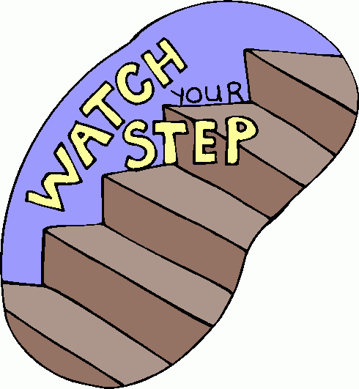

**FOUR STEP PROCESS**

**What is this strategy?**

The Four-Step Process is a **vocabulary** strategy. This strategy helps students to activate their mind when they come across a new word. Students will be able to define the new word and cite relevant examples by drawing it and writing an antonym for the word. With the Four-Step Process students will be able to approach the word from multiple perspectives and discover a variety of ways in which the word can be used. The goal for this strategy is to teach students how to mentally incorporate the Four-Step Process into their every day learning whenever they come across a word that is new to them.

**How do I use this strategy?**

1. Teacher will create a word list of terms that will be used during a new unit.

2. Teacher will supply students with a “Four Step Process” template.

3. Teacher will supply students with a word bank asking students to find a definition of each word they are not familiar with using a separate template for each.

4. Students are then directed to use the word(s) they are not familiar with in a sentence utilizing the box on the template to write the sentence down.

5. Students are then directed to use their imagination and provide a drawing in the appropriate box of what they feel the word means to them.

6. Lastly, the students must decide on an antonym for the new word that will help cause them to understand the word beyond its definition.

**Who will benefit the most from this strategy?**

The Four Step Process strategy is a wonderful tool for learners who need repetition before he or she can commit something to memory. Visual learners also benefit from this strategy since pictures create a great proof in which are easier for some to bring forward in memory when needed.

**FOUR STEP PROCESS**

Blank Template

**FOUR STEP PROCESS**

**Completed Example:**

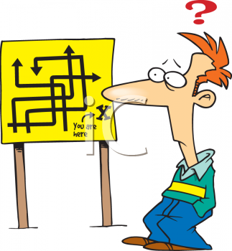

**CONCEPT DEFINITION MAPPING**

**What is this strategy?**

Concept Definition Mapping is a **vocabulary** strategy that is used to teach students to organize key concepts and crucial characteristics of a word’s meaning through use of a graphic organizer. With this strategy, students will describe the concept definition of a word and make comparisons by explain what the concept or the term is and then give examples of it. Importantly the students will need to provide their examples and explanations of the example from their life in order to allow them to make a connection between what they have learned in the classroom vs. the experiences in his/her own life. The strategy itself addresses the importance of knowing how to define key terms and how a term the term connects to lessons throughout the unit.

**How do you use this strategy?**

1. Teacher will select the concept she/he would like the students to know and then choose a key vocabulary term from that concept.

2. Teacher will provide a template to the students of the definition map.

3. Teacher will discuss the components of what a good definition is, such as:

* What is it?
* How can it be compared?
* How can it be categorized?
* What are its characteristics?
* What are some examples of the word/term?

4. Students will then be directed to place the term in the center box, the definition of the term in the box above the term, list items similar to the term in the box on the right and enter examples of the term in the boxes below the term.

**Who will benefit most from this strategy?**

Students who have difficulty with long-term memory process will benefit greatly from this type of strategy. Visual learners will also benefit since picture representation helps students to recall information with less difficulty.

**CONCEPT DEFINITION MAPPING**

Blank Template

Category (What is it?)

Properties (What is it like?)

Illustrations (What are some examples?)

**CONCEPT DEFINITION MAPPING**

**Completed Example:**

Category (What is it?)

Properties (What is it like?)

Illustrations (What are some examples?)

**ABOUT THE AUTHOR**

**Angela wedgwood**

**References**

Billmeyer, R. (2004). *Strategic reading in the content areas: Practical applications for creating a thinking environment.* 1st ed. Omaha, NE: Printco Graphics.

Billmeyer, R. (2006). *Strategies to engage the mind of the learner: Building strategic learners.* 2nd ed. Omaha, NE: Printco Graphics.